**ROLE OF PROCUREMENT & LOGISTICS IN HYDRAULIC & PNEUMATIC INDUSTRIES**

**Abstract**

This research has focused on the determination of the application and significance of Procurement & Logistics systems for reducing transportation cost and time in the Hydraulic & Pneumatic Industries. In order to complete this research, the five chapters have been generated. In the first chapter, the overall rationale and background of the study for justifying the research topic has been discussed. With such a strategy it has been possible to determine the overall impact of procurement planning on the transportation industries in current years. The focus of this assignment is in the different industries. Along with this, it is analyzed that there is the utilization of different components of hydraulic and the pneumatic components. Different industries are benefitted by different components that falls under hydraulic and the pneumatic. ***Resilient Optimization Theory*** is utilized in this study to demonstrate the utilization and the requirement of the different components of the hydraulic and the pneumatic. ***PLC*** model is utilized to determine the process by which hydraulic and the pneumatic components are useful in the case of different industries to get success.

**Table of Contents**

Chapter 1: Introduction 4

1.1 Introduction 4

1.2 Background analysis 4

1.3 Rationale 6

1.4 Aims and Objectives 9

1.5 Research question 9

1.6 Significance 10

1.7 Dissertation layout 10

1.8 Summary 11

Chapter 2: Literature Review 13

2.1 Introduction 13

2.2 Procurement planning and high profit generation 13

2.3 Current transportation techniques for cost reduction 16

2.4 Role of transportation to reduce the delay in product delivery and cost decrement 20

2.5 Role of procurement and logistics in hydraulic and pneumatic industries 22

2.6 Hydraulic and Pneumatic Industries across the World 24

2.7 Theory and Models 27

Chapter 4: Findings and analysis 29

4.2 Findings 29

4.2.1: Theme 1: Significance of Procurement and Logistics for Reducing Transportation Time and Cost and ensuring profitability& Growth 29

4.2.2: Theme 2: Exploring Impacts of Procurement for maintaining safety in transportation sector and to derive Operational Growth 31

References 33

# Chapter 1: Introduction

## 1.1 Introduction

The first chapter of any dissertation is directly associated with a brief background analysis along with generating aims and objectives of the research. A rationale and justification behind the choice of the research topic will be stated in this chapter. This chapter will also have a structure of the dissertation which will help to understand the components of the research paper.

## 1.2 Background analysis

The role of procurement during the time of logistics planning not only contributed in the reduction of cost in transportation process but also controlled the overall time and management of the progress. According to the opinion of Jordon et al., (2019), one of the significant procurement processes is the ***“Lean Management Process”*** which is directly associated with production management as well as sustainability maintenance which are important in the logistics industries in current times. On the other hand, the requirement of the procurement process, especially while transporting some viable items such as foods or medicines, the overall organization and control process should be important in order to maintain the overall quality. On the other hand, the justification behind the conclusion of the procurement process in the logistics services are directly associated with reduction of transportation cost and time along with increasing efficiency. Hence, the large enterprises in the current times area directly relies on the ***third-party logistics (3PL)*** providers which are currently used by the more than 90% supply chain activities in the world (Yang & Yu, 2019). Now the 3PL services are generally used in the procurement process which not only reduces the costs in transportation but also helps in the timely shipping and distribution services. For example, the “***integrated logistics and procurement service (ILPS)”***, is a current service which is provided by Eternal Asia in order to maintain the overall purchasing and logistics purposes unlocking the timely delivery process (Yang & Yu, 2019). Hence, the overall profit of the manufacturer has been seen to be high, presented in the below diagram.

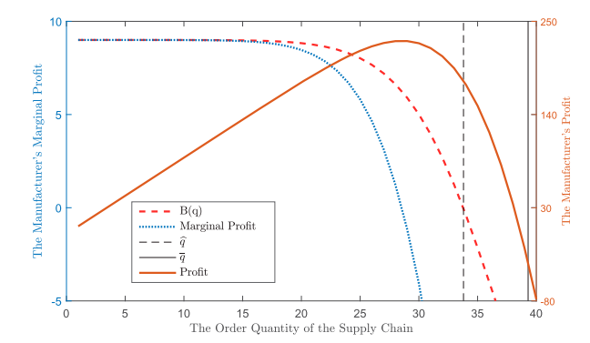

**Figure 1.1: Profit while using procurement process in logistics**

(Source: Influenced by Yang & Yu, 2019)

On the other hand, according to the recent data, it has also been found that the application of procurement recess for supporting the logistics and transportation has been highly beneficial by maintaining the connection and communication with the different types of suppliers. For example, in the case of inter-border transportation and logistics, another procurement method which has been developed by the World Bank is “***The Trade and Transport Facilitation Assessment (TTFA)”*** (The World Bank, 2022). This tool not only helps in trading and logistics progress but also reduces time by improving the operational management. Thus, the overall importance of the procurement process in logistics has been seen as highly essential in contemporary times.

## 1.3 Rationale

In current times, there are some significant challenges that have been determined which are associated with increasing costs and time of the transportation industries across the world. For example, in the case of the UK transpiration and logistics industries, the overall cost of supply chain management along with time has been increased after the hit of the Covid-19 pandemic. In 12% of the cases, the overall barrier for extended payments and increasing cost has created challenges in the growth of the logistics management (Logistics UK, 2021). Therefore, in such cases, the overall import as well as export activities with the country is facing issues, which is required to improve with effective procurement methods.

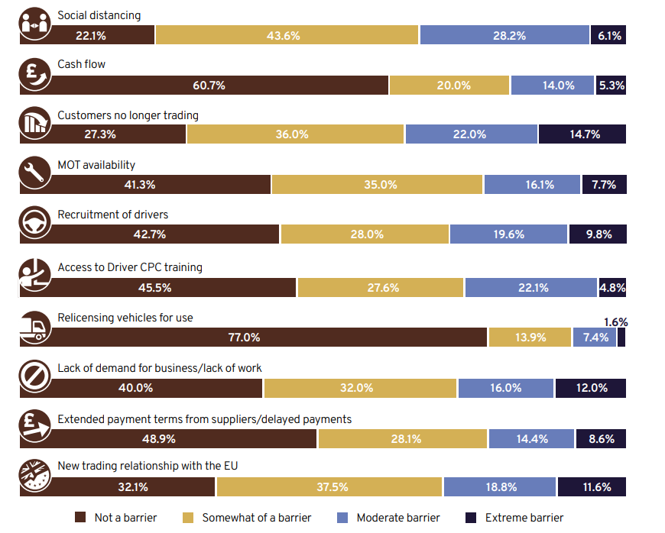

**Figure 1.2: Challenges in the UK logistics industry**

(Source: influenced by Logistics UK, 2021)

Due to some transportation barriers the overall trade value in the UK has been reduced and negative trade value has been generated such as ***narrowed by £11.3 billion in 2020*** (Logistics UK, 2021). As the supply chain process has been distorted due to the pandemic, therefore, the requirement of the overall procurement method would be highly beneficial.

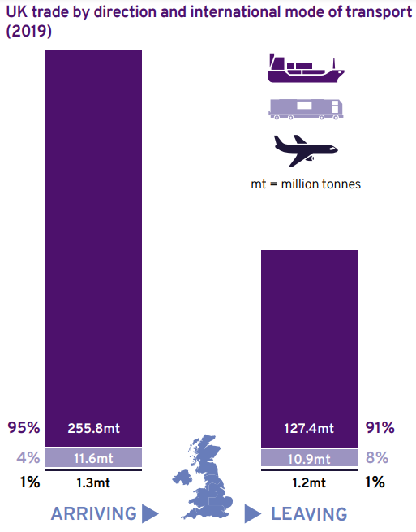

**Figure 1.3: Trade value in the UK**

(Source: influenced by Logistics UK, 2021)

In order to reduce the challenge in the logistics and transportations sectors in current times, the requirement of a procurement model such as “***multiple freight service providers (FSP***s)” engagement will not only contribute to reduction of purchasing costs but also the minimization of travel time has also been found to be there (Nagurney et al., 2019). On the other hand, another beneficial impact of procurement services has also been found to be associated with taking effective decisions during the time of supply chain delivery or logistics trading, which helps in the manufacturing industries. Now in the case of Hydraulic & Pneumatic Industries, the importance of procurement services is associated with making cost-effective transportation decisions as well as profitable development of decisions (Engel-Cox et al., 2019). Hence, this research will shed light on the overall impact of procurement methods in the reduction of cost and time in logistics services in the above-mentioned industry.

## 1.4 Aims and Objectives

The aim of this research is to determine the application and significance of Procurement & Logistics systems for reducing transportation cost and time in the Hydraulic & Pneumatic Industries.

The research objectives are as follows

* To determine the significance of Procurement & Logistics systems for reducing transportation time and cost
* To explore the impact of procurement designing for maintaining safety of the transportation and logistics services
* To understand the requirements of important supplies and services in the Hydraulic & Pneumatic Industries in the UK
* To recommend some innovative techniques for improving procurement design process for logistics and transportations

## 1.5 Research question

The research questions which have been detected based on the research objectives and the rationale are

* What is the significance of Procurement & Logistics systems for reducing transportation time and cost?
* How procurement design helps in the maintaining safety of the transportation and logistics services?
* Which are some requirements of important supplies and services in the Hydraulic & Pneumatic Industries in the UK?

## 1.6 Significance

The scope of this research will be very high, as the overall significance of this topic is clearly seen. In this research, the overall impact of procurement methods for reducing the transportation cost and time in logistics services will be analyzed. As per the findings of UK (2020), in the era of industrial revolution and cutting-edge technology, the procurement process is mostly associated with technology upgradation which ultimately improved the operational efficiency in the supply chain network. Not only that, the importance of the whole approach in Hydraulic & Pneumatic Industries along with some examples will be discussed. Therefore, the overall research will explore some new ideas and conduction of this will have some future scopes. Hence, the significance of this topic is justified.

## 1.7 Dissertation layout

* In the first chapter, the overall background of the research is analysed along with purpose statement
* In second chapter, several literatures has been taken in order to evaluate the importance of the research competes and theories
* In third chapter the justification behind the choice of tools and techniques which has been used for the data collection and analysis has been discussed
* In fourth chapter all the results and findings of the research has been provided
* In fifth chapter the overall recommendations for this researchincludingconclusion will also be discussed

**Figure 1.5: Dissertation layout**

(self-created)

## 1.8 Summary

After the discussion of this chapter, it has been found that overall research is justified and the rationale is directly supporting the choice of research topics. Four objectives have been generated based on the background analysis and rationale of this study. On the other hand, the overall rationale has been supported with UK based data and evidence, which clearly indicates the issues associated with previous concepts. Therefore, the stretch questions generation based on all the background analysis, has also been presented along with a brief significance.

# Chapter 2: Literature Review

## 2.1 Introduction

This chapter is the second chapter of any research which indicates the analysis and review of a range of literature. In this chapter some concepts of the research topics along with focusing on detailed evaluation from the existing literature will be discussed. All the findings from the literature will also be connected to the theoretical perspective in this chapter. This chapter will also have a conceptual framework by pointing out all the keywords and theoretical concepts of this chapter. A gap at the end of literature analysis will also be presented.

## 2.2 Procurement planning and high profit generation

In the area of value engineering as well as supply chain management, the advantages of the procurement process is directly depending on the connection between the suppliers as well the overall operational cost reduction. According to the opinion of Nemati & Alavidoost (2019), there are some significant models which directly indicate the impact of procurement mechanisms in the logistics and transportation sectors such as ***CPLEX 12 optimizer*** which is only available in the ***GAMS software.*** Along with that, this mechanism has also been found to have integrated approaches which ultimately leads to better distribution planning, which reduces the transportation cost and also boosts on-time delivery. Hence, in food manufacturing companies, the requirement of procurement planning is highly important for scheduling of distribution and effective information flow.

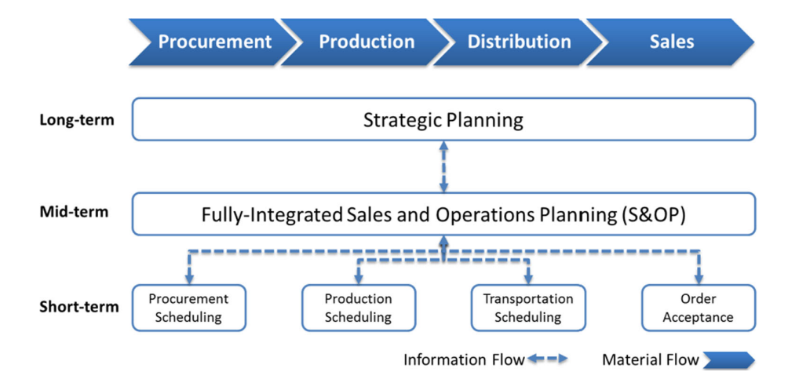

**Figure 2.1: Procurement planning**

(Source: Influenced by Nemati & Alavidoost, 2019)

On the contrary, another piece of literature has also been chosen in order to reduce the significance of curriculum in the case of any public institutions. In any public institution, the overall “***Procurement planning”*** is directly associated with in-depth decision making as well as involvement of all the stakeholders (Chepkesis et al., 2018). In such cases some external authors such as “***Public Procurement Oversight Authority (PPOA)”*** should also be involved. The methods of procurements in such cases which are directly involved with better decision-making are “***cost factor measure (CFM)-integrated concurrent engineering approach***”. In another study, the importance of this technique has been found in the area of reducing the cost of operations. Along with that another significant tool has also been found to be applied by the industries in current times for generating decisions for cost-effective procurement process is “. ***Design to Cost (DtC) processes”*** (Ezpeleta Laskurain, 2021). As per the findings of this state, it has been cleared, application for this progress has been able to reduce the engineering project cost by 70 to 80% and the application of cost estimation model has been highly beneficial in such cases. The overall procurement planning which has been proposed by the authors for reducing the supply chain cost has been discussed in the below image

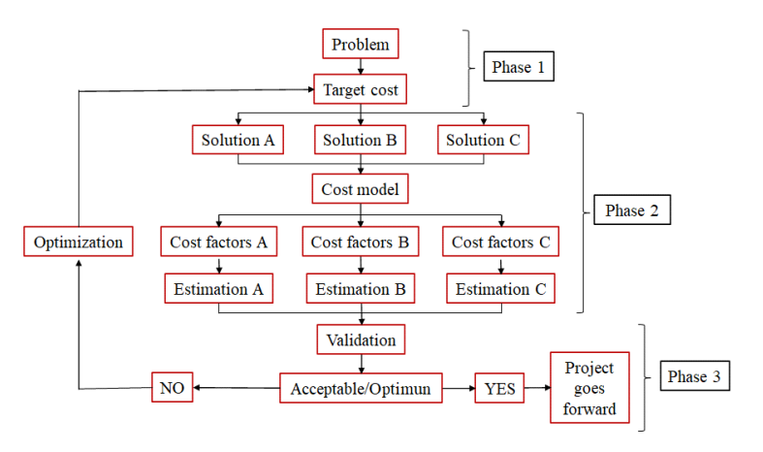

**Figure 2.2: Procurement planning and cost model generation**

(Source: Influenced by Ezpeleta Laskurain, 2021)

Poor procurement practices can lead to the issues of higher operational cost which can be financial loss of any transportation organization along with creating a negative effect of all the resources in current times. As per the view of Changalima et al., (2020), the role of ***“procurement management unit (PMU)”*** whole taking decisions for any organization has been found highly influential along with creating realistic budgets as well as following the public procurement laws. On the other hand, one of the significant findings in this literature was the analysis of the regression calculation for the preparation of procurement plans for any transportation organization which has been presented in the below image

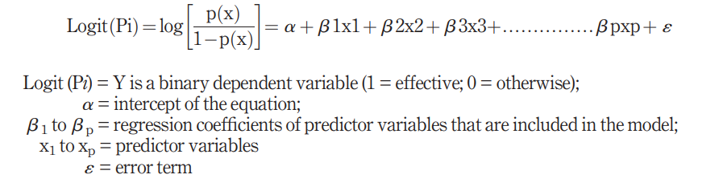

**Figure 2.3: Procurement planning model**

(Source: Influenced by Changalima et al., 2020)

Therefore, it can be said, the requirement of the procurement planning is essential in current times for better cost reduction planning, however, sustainability in such cases is also very important. Gholizadeh et al., (2020), effective and sustainable procurement planning is the key of the competitive success in any transportation industry in current times along with the example of any multi-objective model. On the other hand, due to the increasing application of technologies such as Big Data, the overall approach for procurement planning would be ***“a robust fuzzy stochastic programming approach***”, which ultimately is associated with better decision making.

## 2.3 Current transportation techniques for cost reduction

Reducing transportation expenses automatically is becoming a prime objective whenever transporting goods is a crucial component of any firm. There are various additional factors at work which eventually influence the amount required in the shipment of goods, in addition to changes in market prices, rules set by influence policy, as well as constant increases in fuel costs. Any firm must have an eye for creative yet doable ideas as well as the capacity to create strongly reinforced and successfully execute them if it hopes to reduce operating costs, increase dynamic capabilities, and boost profits (Changalima et al. 2020). Establishing stronger ties with the supply chain's partners, enhancing stock control overall, and implementing better tools which streamline workflow automation are just a few examples of these methods or approaches.

Some of the current transportation techniques used for cost reduction are enlisted below along with justifications:

**Figure 2.4: Techniques for reduce transportation cost**

(Source: Changalima et al. 2020)

***Focus on larger shipment process:*** Focusing on larger shipment process, it could be possible to minimise the cost of product transportation with high relevance. As opined by Chenet al. (2022), in this era of business innovation, most of the organisations all across the globe tries to modulate the mind sets of their loyal customers regarding buying of more products at a time. Motivations are given to the consumers by providing incentives with huge discounts for doing so. In case of the companies, adoption of this technique provides benefit to supply huge amount of goods at a low price. For instance, if any customer orders two different types of products twice within a week, more cost needs to be utilised by the firm in order to transport those. On the contrary, if ten products are ordered at a time, cost of shipment can be less or per product. Consideration of this process is beneficial to optimise space for warehouse and scope of damaging of products can also be minimum.

***Consideration of multiple modes of transport for ensuring flexibility:*** In case of the conventional way of product transportation, it is observed that only one mode of transport is used to deliver products for all customers. However, Chepkesiset al. (2018) claimed that value of shipment process is degraded in a negative way while considering only a particular way of product transportation. Based on this thus circumstances, multichannel shipment process is another technique of transportation considered by almost all of the marketers nowadays for enhancing their business flexibility. For establishing this technique, it is required from the end of marketer to choose less expensive mode of transport and combine ample of product transport channels simultaneously for driving saving of cost and enhancing flexibility in business operation.

***Always try to prioritise the satisfaction level of customers:*** Growth of any business is directly associated with meeting the satisfaction level of customers as they are the major stakeholders for increasing sales volume and profitability of any organisation. In the words of Donget al. (2022), serving better to the customers enable easier scope of negotiation and to some extent, high quality product at a premium price can be accepted. For instance, it is the duty of business administrators to find out the preference level of customers and offer products to them accordingly within the expected time. By doing so, it is possible to manage logistic system in a better manner and scope to gain high reliability in business process can be acquired. All the global marketers have reflected positive correlation between happiness of customers and greater chance of cost saving.

***Adoption of digital technology for process automation:*** Digitalisation of business is the prime need for organisations to get success in global platform. Similarly like any other business process, shaping of procurement and logistics management can also be possible through adoption of advanced technologies. As per the view of Ezpeleta Laskurain(2021), automated technologies are beneficial to manage warehouse by reducing manual errors and this has resulted in low amount of product damage and saving of cost. Efficiency of any business can be enhanced in a positive manner with the help of the mentioned strategy and the entire cost of production can be minimised significantly. Supporting this fact, that both inbound and outbound logistic processes like “negotiating freight rates”, “shipment tracking” and “invoice reconciliation” are managed properly with the help of automated procurement management system. Through adoption of digitalised process, it becomes possible to optimise the overall transportation cost of business operation and resilience in business performance can be achieved. Effort of human resources can be minimised by considering this technique and there is a scope to gain more reliability in business operation and its proper execution along with reduction of expenses for streamlining product transport.

***Advanced data analytics and increase operational flow:*** Recording of transportation data is a must need for developing future operational process and in this regard, reduction of unnecessary expenses utilised for business purpose can be possible. As opined by Gholizadehet al. (2020), supply chain management of recent ear is highly driven by data analytics through which tracking of all the information can be easier. In order to assess the prior data, it becomes quite easier to review about the best service providers and drawing conclusion between two or more service providers regarding their business performance can be analysed properly. Proper evaluation of present-day performance of any firm allows to recognise the ways through which total shipment cost becomes less and cutting down unnecessary expenses an also be possible (). Therefore, well-accounted decision-making for transportation process becomes possible with the help of this tech-friendly strategy and scope to generate more revenue can be possible.

***Try to achieve end-to-end visibility of supply chain:*** Development of end-to-end visibility for supply chain management is required that in turn could be impactful for increasing efficiency of procurement and logistic process. According to the view of Jordonet al. (2019), through access of real-time information about products and service, logistic network can be broaden for any business. In this regard, fair discussion with both the internal and external stakeholders enable to understand both the priority and flaws at the same time and resilience in business performance can be achieved. Combined action of virtual and conventional technique provides relevance in terms of management of transportation cost and gaining valuable insight about business becomes easier through this.

## 2.4 Role of transportation to reduce the delay in product delivery and cost decrement

The two main elements which impact the selection of goods transportation mode are the transit price that the carrier charges the shipper as well as the level of service. For review transit systems realistically and enable carriers to fully understand the shipper's need for high-quality service, numerous fundamental strategic might well be defined in terms of additional expense. The price of operating with a carrier could be used to summarise a number of these elements that have an impact on the shipper's inventory overhead expenses but are generally less known by carriers. The TLC of using the appropriate form of transportation can be calculated.

It is the sum of all expenses related to employing a particular technique or service for commerce, including transportation, inventory upkeep, and other expenditures. Additionally, the total logistical costs incurred by the shipper could be used to evaluate shipment rates. When it comes to mode choice, the “inventory theoretic model of freight transportation” considers total logistics costs (TLC). The TLC of each transportation modes is influenced by a number of risky situations. The “inventory theoretic model” is used, with a focus on the shipper's viewpoint on the doubtful assessment. Straight road hauling as well as multimodal transportation are compared in this investigation. Following the outcome of the single variable study, the responsiveness of two factors is examined. The Monte-Carlo method is employed to calculate the probabilistic model of TLC in uncertain situations.

TLC could be employed to examine each probabilistic model for these two transportation modalities. The choice is made to employ a delivery technique with a reduced TLC. The majority of existing models whether dismiss or overgeneralise expenditures as well as capabilities, commonly presuming that there is simply one practical method of transportation, despite the fact that shipping costs make up a significant proportion of operational cost and also that inventory models might also begin taking transportation into consideration. It is increasingly extra challenging to predict and choose the optimal method of transport or mixture of options because of the rich complexity of transportation options and cost patterns as a result of deregulation. This study analyses and groups inventory approaches for different types of transportation, with a focus on the shipping function optimisation, mode features, as well as accounting approaches for numerous methods.

## 2.5 Role of procurement and logistics in hydraulic and pneumatic industries

Hydraulic and pneumatic systems are largely used by almost all the global business sectors for accelerating organisational operation and gaining success within competitive marketplace. In this regard, high maintenance of procurement and logistic systems are needed through which gaining of reputation and profitability becomes easier. All kinds of manufacturing and assembly activities employ pneumatic equipment. They could be deployed to push stuff in service facilities as well as on production lines. The technique known as pneumatics employs pressurised air, namely the power stored in the pressurised gas, to activate machinery. At the enormous scale, this technology has an extensive range of applications and usages and it has greatly aided in the process of automating commercial operations. Cylinders, motors, and other machine systems are moved by pneumatic systems using air or pressured air. Numerous industries, notably building, medical, and manufacturing, the automobile industry, and numerous others can benefit from pneumatics technologies.

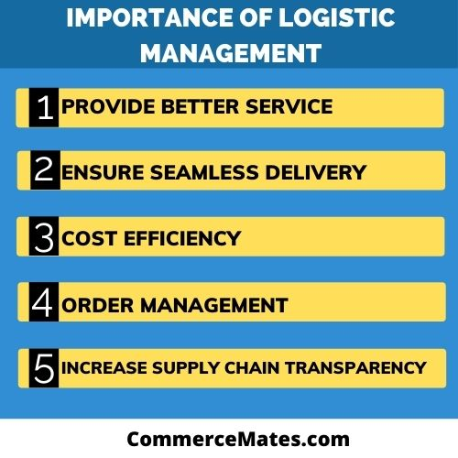

**Figure 2.5: Importance of logistic management**

(Source: self)

Higher force can be applied by hydraulic systems compared to physical, electromagnetic, or pneumatic equipment, which can move bigger loads. Due to its liquid power system, this could handle a wide range of weights without the necessity of gears, pulleys, or cumbersome ends. The primary role of a hydraulic fluid is to transfer electricity through the network, allowing for the accomplishment of work and mobility. Additionally, lubrication, heat transmission, and pollution prevention are performed by hydraulic fluids. Hydraulic actuators are designed to generate force or movement.

“Transportation and delivery”, “storage”, “packaging”, “cargo handling”, “distribution handling”, and “information processing” are all parts of logistical issues, as well as numerous methods have mostly been set up to carry goods again from manufacturer or site of creation to the customer promptly and on schedule. Acquisition logistics is fundamentally about finding the raw materials required to produce things. In other terms, this section of the distribution network is concerned with buying the goods that the production process needs to function, such as operational materials, supplementary equipment, repair parts, or even natural resources. In inventory control, transportation is critical and its proper management helps to gain resilience in business service. It is employed to schedule and coordinate the efficient, secure, and scheduled transportation of goods.

Procurement and logistics management plays an important role for both hydraulic and pneumatic industries as the processes are directly related with enhancing scope of product shipping. Demand for the products offered by hydraulic and pneumatic industries are enhanced gradually day-by-day and it is the major reason for proper inventory control. Effectiveness in transportation converts in company into greater productivity, cheaper costs, high manufacturing speeds, better stock management, more efficient utilisation distribution centre, improved supplier and client contentment, and enhanced experiences for customers. It enables businesses to interact with clients in an effective manner as well as offer them prompt, high-quality service. Therefore, efficient logistics activities provide clients with great value, which in turn enhances the image of the company. Firms can succeed by providing enhanced customer solutions. Logistics helps to lower costs and increase productivity. Logistics approach helps companies to cut costs across the board, including shipping costs to the quantity of storage space needed, by successfully applied sales volumes. Henceforth, hydraulic and pneumatic industries have to consider suitable logistic process to generate value in global market with high efficiency.

## 2.6 Hydraulic and Pneumatic Industries across the World

Besides the ***Automotive Industry,*** the segment of hydraulic, and the pneumatic industry is becoming the eminent sector for the utilization of honing procedure. It is ensured by the optimized surfaces that there is a great precision of the components. There is an increase in the capability and longevity of the elements. A lot of industries are there which have their dependence on the seals that are both hydraulic, and the pneumatic for carrying out operations per day. The description of the best 10 industries is those that have their dependence on seals that are both hydraulic, and the pneumatic.

**a) Agricultural Machinery**

As there is an increase in the growth of the population of world, there is an increase in the requirement of the harvest of crops and it requires more efficiency. In this case, there is a requirement for the machinery that is sealed by hydraulic and the pneumatic (Deaconescu& Deaconescu, 2022). The power machinery that is hydraulic and the pneumatic in nature is of great quality and permits agricultural machinery along with different equipment of farms for the maintenance of peak performance. Hydraulic seals that are single-acting are utilized by farm equipment for harvesting, threshing, baling, and draining, as well as, the machinery of crop harvesting.



**Figure 2.6: Hydraulics and Automation**

(Source: Deaconescu, & Deaconescu, 2022)

**b) Machines of Amusement Parks**

There is an absence of completion of the summer supply without the roller coasters. Pneumatic and the hydraulic seals permit the rides of the amusement park for keeping the functions in a perfect manner. Rides of Amusement parks by which there is the utilization of the specifically designed sealed equipment that are hydraulic and the pneumatic possesses minimal seals of friction and the rubber, TMCF seals, polyurethane and the wipers are very much reliable.

**c) Manufacturers of Automobile**

The Assembly department of all automobiles heavily depends onthe pneumatic rams on the assembly jigs. The characteristics of Pneumatic are cleaner, as well, quieter and the leak is prevented from the contamination of different parts that the vehicle has.

**d) Manufacturers of Cheese**

Cheese is one of the important components that is utilized in the household of every country. A world without cheese is unimaginable in the current scenario and within the cheese industry, there is a dependability on pneumatic seals to manufacture and packaging machines. With the help of hydraulic and the pneumatic seals, the working and the functioning of machines are improving day by day.

**e) Equipment for Coal Mining**

Hydraulic is utilized by the machinery of underground machinery and the machinery of roof support uses pneumatics (Chen et al., 2022). The first priority in the mining industry is safety and both hydraulic and the pneumatic seals are considered in this case to keep the maintenance to the minimum and the performance to the maximum.

**f) Concrete Pumping**

The requirement for high-quality hydraulic, and the pneumatic seals are there within concrete pumping is there. The requirements are there for the prevention of the dangerous blockages within the system of the pump. There is a suitability of these seals in the case of hydraulic rams utilized for the operation of the plungers of concrete pumping, as well as, hydraulic rams above the boom.

**g) Manufacturer of Textile**

The utilization of pneumatics is there in the case of the manufacturer of Textiles for the collaboration with the compact spinning, the high pressures along with the constant rotation that is acquired by air rams. As there is a continuity in the increase of the population of the world, there is an emergence of clothing and hence, pneumatic seals are useful in this case.

## 2.7 Theory and Models

The theory that is suitable in the case of the Hydraulic and Pneumatic Industry is the ***Resilient Optimization Theory***. It is said by this theory that the importance is there in the process with the help of which the dealing can be possible, and as per this theory, the issues within the hydraulic systems (Dong et al., 2022). Several issues are observed in the ***Food and Beverage Industry.*** High temperatures, pressure, as well as, speed have the conditions that happen often within the industry. The explanation of the reason for which hydraulic and pneumatic system performs a broad variety of tasks from the shifting of the ingredients.

In addition to that, with the help of this theory, there is an understanding of the different tasks that these systems perform within different industries and the requirements of the systems within the different industries. In this context, the example of the Beverage Industry is applicable. One of the most common elements of the Pneumatic cylinders within the conveyance systems of Food and Beverage (Kungwalsong et al., 2022). This is because it is very simple to keep neat and they are very compact, and they are a reliable method of the generation of the motion.

There is the utilization of strong hydraulic motors in the conveyance and the hydraulics and the pneumatics have figured profoundly within the procedure of the conveying of the oil of food-grade and liquids into the correct destinations at the time of processing. As opined by Röhm, & Anderl, (2022), The model of ***Product Life Cycle (PLC) is*** apt and appropriate in the case of the Hydraulic and the Pneumatic Industries. In addition to that, the four stages of this model are explained in the context of this industry. When there is a launching of the first product within the industry, there will be typically low sales, and the slow growth is there.

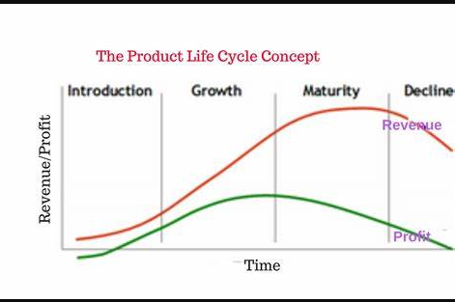

**Figure 2.7: Stages of Product Life Cycle**

(Source: Röhm, & Anderl, 2022)

The profit of the company that utilizes the Hydraulic and the pneumatic components is not very large due to the latest and untested product. There is a requirement of important marketing attempts in the case of products related to hydraulic and the pneumatic as unwillingness may be there in the case of the consumers. There is an absence of the advantages from the ***economies of the scale*** as there is an absence of the maximization of the capacity of the product. Within the Growth Phase, there is a continuous prosperity of the product and the needs of market is met by products that are generated to hydraulic, and the pneumatic.

Competition within the stage is fierce with the competitors like Automotive Industry as it has a fame in the market. There can be an increase in the sales of the companies using Hydraulic, and the Pneumatic components by attracting latest consumers to the offerings of the products. The market to efficient, as well as, there is a decline within the growth of sales. Pierce undercutting along with expanded promotional efforts there within the stage are quite common as the companies in this industry attempt to capture the consumers from the rivals in the maturity phase. The last stage is the stage of Decline in which sales of the products of hydraulic and the pneumatic begin to fall. In addition to that, there is a decrease in the advantageousness of the company. In this stage, therefore, there is the involvement of numerous strategies like the reduction of the marketing efforts along with the maximization of the life of the hydraulic and the pneumatic product.

# Chapter 3: Methodology

## 3.1 Introduction

The importance of procurement functions in logistics which is immediately associated with the supplies. Apart from that, procurement managers identify procurement facilities to maximise supplier power. In order to positivism research philosophy is also important for sustainable development. Identifying the associated risk of the business is mandatory and that can effectively maximize4 future opportunity. In order to, sometimes sustainable development can highlight the financial structures. The role of the procurement is involved by the logistic planning which is not only contributed by the time management. The effective business structures of the organisation is necessary and that can able to identify hope to maximize lean management process.

In order to, lean management process also important and that can able to find out how to justify the procurement process. Most of the business organizations are trying to identify how to improve the financial structure and that can be maximize the major structure. The significant production management also important to manage the lean management and that is necessary to identify the lean management process. The overall organization is focusing on the financial structures which are efficiently managing the procurement difficulties. In order to, maintain the overall quality of the organization is mandatory which is efficiently managing financial structure.

## 3.2 Research philosophy

Positivism research philosophy considered for the specific research which is considered as best approaches in the business. Most of the business organizations are using positivism research philosophy and that can able to find out how to maximize the major return. Apart from that increasing the work capacity of the organization is necessary which is necessary for the business development. The realistic understanding of procurement analysis also needed and positivism research philosophy is the important option which is considered for the common research (Mohajan, 2018). In order to, maximize the knowledge of future researchers positivism research philosophy considered as effective approach.

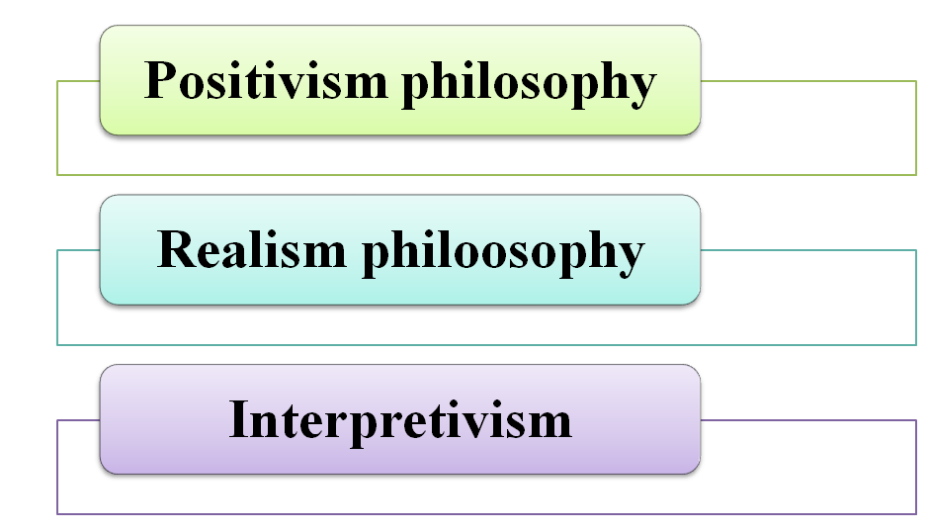

**Figure 3.1: Research philosophy**

(Source: self-created)

Apart from that positivism research approach has considering how to fruitful practical application to improve future scope. In order to positivism research philosophy also considered as an effective approach which is necessary to increase the knowledge of the future researchers.  Most of the business organisation a trying to using positivism research philosophy to continuously improving innovative structure to maximize the future scope. Apart from that establish new opportunity in the organisation positivism research philosophy is applicable and also increasing the maximum capacity.

## 3.3 Research approach

Detective research approach has been considered for the specific Research and also necessary to increase the knowledge and skills of the future researchers. On the other hand inductive research approach also considered for the individual research but which is time consuming and skill and knowledge also required for that research approach (Patel & Patel, 2019).  In order to maximizing the capacity of the organisation a deductive research approach a different rule and also identify how to eliminate major barrier of the research. In order to improve the research process of the organisation specific research approach has been considered and that effectively maximise future scope along with minimising the difficulties.

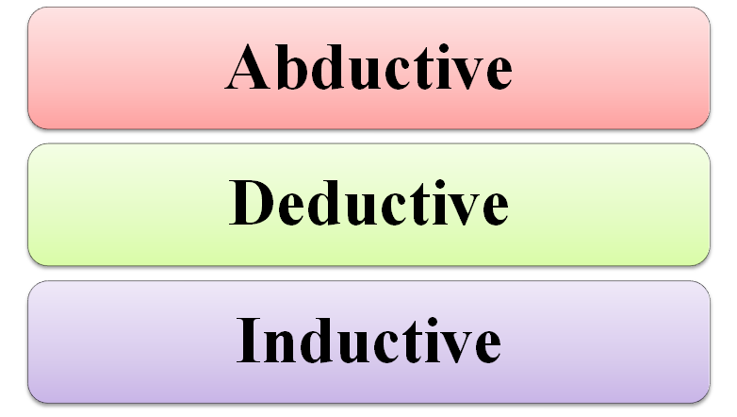

**Figure 3.2: Research Approach**

(Source: self-created)

Apart from that large Enterprises for trying to identify how to complete the project within the deadline. Detective research approach currently using for the common research that also effectively minimising the cost of the research. In order to maximizing the overall profitability of the organisation reductive research for approach always following and managers are trying to reach the goals and objective by using deductive research approach. Apart from that identify the Logistic difficulties of the organisation a detective research approach play innovative rule and trying to improve integrated logistics system.

## 3.4 Research design

A descriptive Research Design also considering for the specific Research and also increasing the major capacity of the research.  In order to maximizing the Future opportunities for individual researchers at time to develop their knowledge and skills and descriptive Research Design is a useful approach for that. Without proper Research Design in research cannot be easily conducted and that do not identity file how to we solve the major barriers during the complete situation. In order to individual researchers at time to highlight the major barriers by using Research Design and time to time eliminate them to improve research structure.

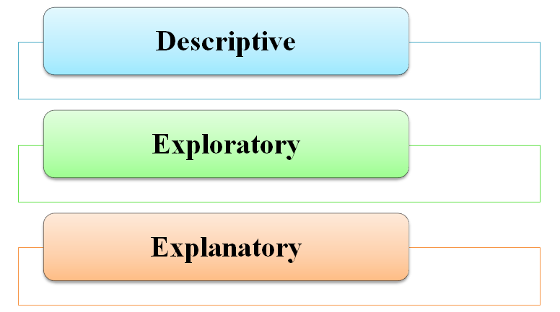

**Figure 3.3: Research Design**

(Source: self-created)

In addition sometimes exploratory and explanatory  Research Design also considered for the individual business organisation but descriptive Research Design also more efficient and that accurately make creative ideas to improve Research Design (Dźwigoł, 2018). From that Research Design also required to improve the research structure and future Richard researchers are getting increasing their knowledge and skills by using appropriate Research Design.  In order to improves the major capacity of the research the knowledge of the future researcher’s also necessary and descriptive Research  design makes positive support to the individual is ages to gain innovative knowledge and skills.

## 3.5 Research sampling

Purposive sampling has been considered for the specific research and that easily find out some necessary information which is important to justify the research hypothesis. Research sampling process is also important which is creating researchers aptitude and improve creative ideas to minimise the barriers. In order to improve the financial health of the  organisation purposive sampling is the accurate option which also maximizes the capacity of the research.  In order to complete the research within the deadline a purposive research sampling played great role. The authentic Data Collection process have been using for the specific Research and Research sampling process also necessary to considered the data collection process.

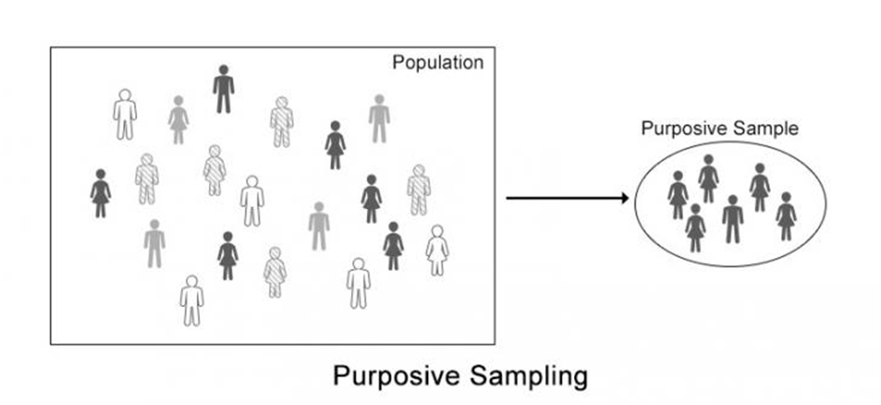

##### Figure 3.4: Research Sampling

(Source: Newman & Gough, 2020)

High efficiency level of the research always considered by the purposive research sampling. In addition specific research sampling collects numerous information for the business to grow  more future scope. Apart from that extreme and critical is the process that purposive research sampling is classified but that comes under theoretical invention. In addition purposive sampling is necessary techniques to highlight the deductive research approach. In order to, improve the current service of the management purchase and logistics department Identify the overall profit of the individual manufacture.

## 3.6 Data collection

The primary data collection method is useful option which is considered for the specific research and that slowly independent to identify the active participant of the research. In order to describe the graphical representation of the data primary data collection method also useful option and that can be considered from the survey for the interview questionnaires (Newman & Gough, 2020). Qualitative Data Collection method is useful metrics to identify the current position of the research and that maximize the knowledge and skills of the future researchers. In order to identify the appropriate research topic in is necessary for the business and that can effectively maximize how to improve the major return of the organisation.

In order to graphical presentation also required to highlight the major structure of the organisation and researchers are trying to develop their skills and knowledge by the collecting of the data. In order to data collection method describes the current situation by the graphical presentation and that effectively interpret the current position of the research. The graphical interpretation also needed for the specific Research and that ethically identify potential information which is conducted for the research (Basis & Polaris, 2018). Data are easily collected from the data collection method and which is time sufficient and that considered as major opportunity of the primary data collection method.

## 3.7 Ethical consideration

Ethical consideration of the data is properly Describe how profit can be divided by the individual  researches. In order to improve knowledge and skills of the future researchers ethical consideration approach play role and maximize future opportunity which is conducted for the research (Ngotwane, 2018). In order to identify the field of the researches consideration the innovative ideas and decision making process also needed which is ethically eliminate all the barriers which is important  to increase more future scope.

The ethical consideration also followed by the individual company and the policy of the ethical consideration also important for long term growth. Sometimes a search cannot be conducted due to ethical consideration and researchers are trying to identify the major reason of the research barriers and trying to minimise them by the innovative ideas.  Ethical aspects  are necessary to generate more future scope and that considered as important factor to identify the policy to maximise future scope (Babied, 2020). To identify the profitability aspects of the research ethical consideration play different roles and researchers are trying to identify the reason how to maximize the profitability.

## 3.8 Data analysis

Research is based on the primary data collection method which has been done to collected necessary information’s. In order to, data analysis methods also important to identify how to maximize the major return and analysis can be depending on collected data from the internet or the other public resources (Raga & Arisha, 2018). In order to illustrate the important ideas are necessary for the organization which is effective for the future researchers. Draw a systematic pattern of the research data analysis method always depending on the data collection and that describe accurate information based on the collected data.

In order to identify the financial position of the research data analysis method also necessary and which illustrate some innovative idea to maximize the future scope. Information is necessary for the individual research (Wilmot, 2020). In order to, identify the collected options are eligible or not for the research  data analysis method is the important options. Most of the business are trying to identify how to minimizing the barrier of the organization. During the same retime the country is facing major issues which is creating major barrier.

# 3.9 Accessibility, reliability and validity

Whether collecting primary or secondary data, accessibility of information often seems challenging. Since this study primarily focuses on collecting primary data, the access of information is a problem, as finding target audiences or participants is difficult, platforms used often because technical problems, such as poor connectivity, website interruptions caused by bugs, and so on. In order to, identify the available information’s are required for the specific research and that can able to identified how to maximize the future scope. In order to accessible and reliable data are more efficiently collected in important information creatures easily developing the future scope.

In order to, individual participants are trying to identify how to maximize the major opportunity which is effective for the future scope. This research is basically considered the primary data collection method which is identifying how to analyze the effective information to involve reliable options to the research (Greening, 2019). In order to analyse the current financial health of the organisation it is necessary and that can effectively maximize how to get maximize return. All the competencies of the research based on the analysis of the data which is efficiently identify how to be primary data analysed.

# 3.10 Summary

Based on the above discussion the methodology chapter also consider how to conduct a research which is effective for the future. In order to, individual firms are trying to identify how to collected important data which is necessary for the business. During the analysis of the data most of the organizations are trying to identify how to analyze the individual firm’s performance. Without proper research design research do not resolve the difficulties and that can directly affected the research performance. In order to, descriptive Research Design also more efficient and that accurately make creative ideas to improve research structure.

In order to future researchers are trying to identify how to maximize the major opportunity which is effective for the future growth. Most of the business organizations are using positivism research philosophy and that can able to find out how to maximize the major return. In order to, an effective business module is necessary and data collection methods collect sustainable data and analyze them to identify how to become research difficulties are minimized. In order to, several platforms are trying to using appropriate research design and that less time consuming and lower expenses also required maintaining it.

# Chapter 4: Findings and analysis

## 4.1 Introduction

This chapter is going to evaluate logistics and procurement regarding information and its impact on the pneumatic Industry. This chapter is going to conduct a different approach regarding explanation about logistic and procurement activities based on previous conducted reports.  Logistic and procurement activities based on previously conducted reports Finding analysis regarding pneumatic industry would be evaluated through collecting information based on previous journals and data sources to conduct and outs of the research. The researcher is also going to be placed to depend on analysis based on findings regarding the document process for the pneumatic industry. Collective information would be conducted through justified and authentic resources that value the impact of logistic and procurement bosses to the pneumatic industry by delivering critical analysis of productivity growth. The research objective related find outs would be conducted through finding regarding pneumatic activities to enhance growth identification and operational activities to identify pneumatic Industries activities and productivity growth by Logistic and procurement operations support. Research is also going to conduct for identification of analysis and findings regarding registering a procurement activities' importance to pneumatic industry that is going to summarized this chapter's importance in this research.

## 4.2 Findings

### 4.2.1: Theme 1: Significance of Procurement and Logistics for Reducing Transportation Time and Cost and ensuring profitability& Growth

The primary theme associated in the findings and analysis section of this chapter is considered to be related with determining the significance of procurement and logistics for reducing transportation time and relevant costs. Significance of appropriate time management for complying with necessary operational activities is further deemed to be an essential trait for prompting better operational aesthetics. As idealised and narrated by Gencer (2019), the relevance and significance of procurement and logistics with respect to reduction in transportation time and costs can be associated with ensuring planned stages of operational activities. The planned and sequential stages of operational activities is further considered to be an essential aspect which in due course leads to vast reduction in transportation costs and time. Hence, the reduction in transportation costs and time catapults to leading prospects of profitability generation, which thereby encourages growth and progression of a particular concerned organisation.

The hydraulic and pneumatic industry is further considered to be an essential sector in any economy to propagate high skilled engineering and technical services. The high skills required for engineering services can be further associated with combining integration of skilled labour along with staged completion targets. Thus, an organisation involved in this industry can further complement better time allocation and cost savings when all operations are conducted within prescribed specifications and requisite legislations are being adhered fruitfully. As per opinions and illustrations of Alfnes *et al.* (2021), the fundamental strategy that could be adopted to reduce transportation time and costs consists of fixing a particular mode of transportation. Generally, the available modes of transportation are considered to be railway, roadways, airways and ships and fixing a particular mode of transportation further benefits an organisation to comply with cost savings. In an ideal scenario, air transportation is given more preference as it compensates for lower time, however the cost factor could be a concern in the near and distant future.

Relevance and significance of procurement and logistics for reducing transportation time and costs can be further addressed duly by a hydraulic and pneumatic organisation when over reliance on labour is being reduced. In order to reduce the over reliance of labour for production and operational activities, the concept of automated loading can be implemented to nullify lower labour costs. Hence, in this manner the operational swiftness and efficiency can further increase leading to better production prospects for the company Fargnoli, Haber & Tronci (2022). Moreover, the logistics cost reduction tactic could be simultaneously used to ensure least costs by creating a potential cartel of buyers involved in the overall production cycle for an organisation. In this manner, costs can be reduced within a particular time frame leading to high operational profits in the relevant industries and the markets.

### 4.2.2: Theme 2: Exploring Impacts of Procurement for maintaining safety in transportation sector and to derive Operational Growth

The exploration of impacts for procurement associated with maintaining safety in the transportation sector and to serve operational growth is further deemed to be an essential parameter needed to be addressed duly by hydraulic and pneumatic organisations. The fundamental importance needed to ensure detailed safety measures in the transportation sector can be associated with following all relevant safety measures and guidelines to comply with healthy prospects of operational conduct. As per narrations and explanations of Liu, Liu & Choi (2022), the technical aspects of maintaining safety in the transportation sector environment need to be considered with respect to harnessing safety as well as safety with regards to handling of freight and cargo. The failure to comply with these requirements could attract a large plethora of implications which could essentially lead to improper business aesthetics for the concerned pneumatic and hydraulic company. As this industry is mostly associated with handling of precious metals, lapse of safety is therefore discouraged and could implicate financial and operational penalties.

Further important impacts of the supply chain in the transportation industry are considered to be related with the implementation of the five step model to propagate essential growth and progression in the transportation industry. As per narrations and explanations of Cherier, Bennekrouf & Meliani (2020), the additional impact can be associated with respect to instigating a proper and streamlined process for facilitating the conduct of operational activities in a pneumatic and hydraulic based organisation. Hence, it could be considered that a perennial lapse in any of the stages in operational conduct and operational activities would lead to higher financial and operational implications. Subsequently, an organisation is considered to be accountable for ensuring all relevant paperwork and documentation is being maintained thoroughly. Hence, compliance to bill of lading and other relevant documents is needed to be kept at bay in order to facilitate healthy operational conduct over a prolonged time span.

The additional aspects and features of the impacts of procurement can be attributed with respect to selection of credible suppliers. As per narrations and explanations of Hashemi *et al.* (2020), the credible selection of suppliers is considered to be an important facet to procure raw materials at a faster rate as well as experience lower costs of procurements. Hence, the process of bidding and tendering is being encouraged fruitfully to acquire new suppliers within the least time frame. However, the failure of attracting an appropriate supplier within a lower time frame could lead to overshooting of costs and expenses, thus reducing operational growth, financial credibility as well as transportation credentials in the industry and the markets.

### *4.2.3: Theme 3: Understanding important facets of time Management to comply with hydraulic and pneumatic industries in UK*

Time management activities in operational management in pneumatic Industries potentiality huge potential in regard to the procurement process. Additional requirements about time management activities in the pneumatic industry are important because of delivering energy to supply customers. The logistics and procurement process need to be effective in managing the whole operational activities of business to identify a requirement about customers and provide service according to their expectations.

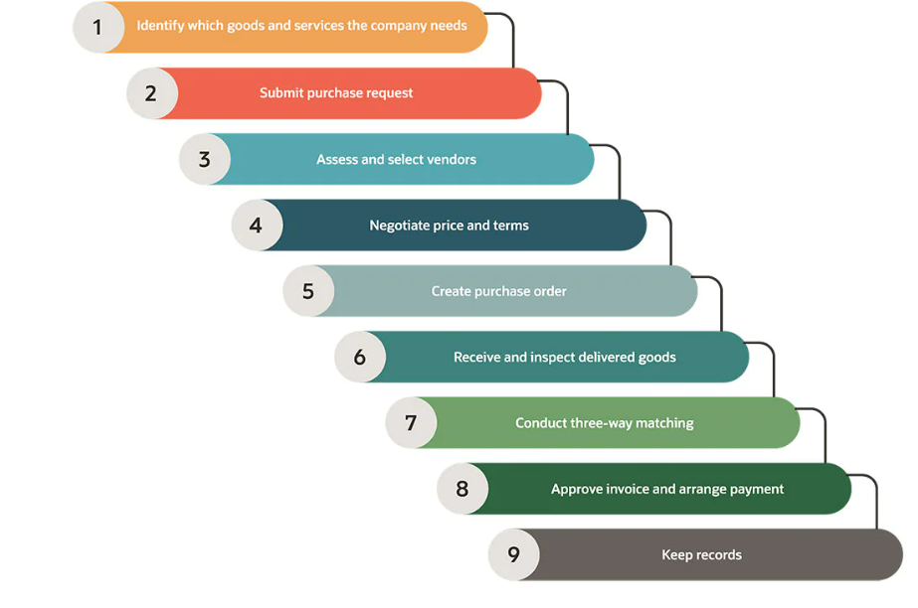

**Figure 4.1: Procurement process**

(Source: Kołakowski, 2022)

Logistic activity for the pneumatic industry would be evaluated by operational growth opportunities to distribute the whole productivity of the pneumatic industry with sufficient flow of products according to supply. Based on previous journals regarding logistic support organization to maintain resource management continuous logistic process that helps to deliver a sufficient amount of product to clients and fulfil requirements of business growth. According to previous journals and collecting information through internet sources has confirmed logistics support in pneumatic in dost developed supply chain management with better output.  Cited by Karpova, (2019), logistic population consists of distribution productivity supplied to clients within allocated time, where operational growth of this industry would be affected by Logistic growth through proper management of resources.  Based on the operational activities of the Pneumatic industry that produce energy and supply to customers, the logistics corporation plays an important role in maintaining the balance between demand and supply. This an organization involved in this industry can further complement better time allocation and cost savings when all operations are conducted within prescribed specifications and requisite legislations are being adhered fruitfully. Cited by Kołakowski (2022), logistic support importance to the pneumatic industry has been considered as an associated flow of productivity support through the use of minimal resource use.

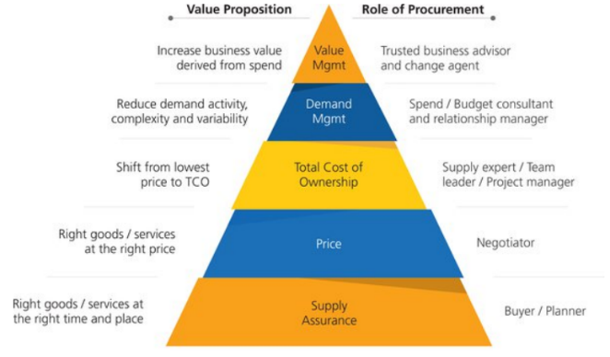

**Figure 4.2: Productional activities of pneumatic industry**

(Source: KAMENDU, 2020)

Procurement process to this industry has been conducted through poppets resource allocation and using proper techniques to produce energy suppliers. Cited by KAMENDU (2020), pneumatic industry produced by compressing air and generating energy resources for customers. Procurement process of the pneumatic industry with different steps identification of product requirement as per client cement that would be produced by existing resources of organizations. Counting the list of suppliers for raw material has been conducted in the procurement process that helps the pneumatic industry to gain advantage and diversify its supply chain.

Negotiating contract terms with clients becomes essential to gain profitability, where pneumatic industry advantage by using different supply chain management helps to reduce cost of production.  Cited by Dhakal (2020), competitive advantage in the market would become manageable by adopting a lower cost of average production that helps to place the purchasing price of the product at a minimum level to competitors. Organizational productivity in the pneumatic industry has been developed by adopting Logistic support that helps to gain the patient flow of resources also delivering produced energy to customers. Logistic tools of organization oriented with different types of machinery techniques however pneumatic industry logistics support through warehouse management. Logistic programs of the pneumatic industry produce efficiency in distribution of energy to customers that not only improve is organizational productivity and profitability of this industry. According to Changalima *et al.* (2020, Supply related programming has been organized in this industry through collecting of resources from suppliers, distribution of connectivity source to specific department of Pneumatic industry production, after productivity of energy it has been distributed to this supplier through supply chain management of logistics process. Logistic support organization required to supply energy to organizations that could be able to determine pm production as per demand.

### *4.2.4: Theme 4: Innovative Techniques needed to be encouraged for improving procurement design process in logistics and transportations*

Innovative techniques for procurement design in the pneumatic industry Develop productivity of all operations with connecting of resources. Logistic support for the pneumatic industry depending on continuous communication with different departments and also preferred to evaluate productivity of the organization by the source management activities. Cited by Cipriani *et al.* (2021), innovative techniques like AI based communication activities establish communication among employees to regenerate better productivity. Cited by Odume *et al.* (2020), operational approach in organization would be effective to gain knowledge about AI based communication system innovative productivity by proper resource of management. The procurement management process in the pneumatic industry improves organizational productivity by reducing waste management approach.

Machine learning program in Logistic and procurement head to improve voice the whole operation for pneumatic industry because automatic machine learning installation in Operation is going to produce beta results with minimum human errors. According to automated machine learning programming installation in the pneumatic industry improvised productivity by using minimum resources that reduce cost of production. Machine learning programming activities initially required investment that might lead to financial crisis for a limited time period after a certain time period to be the beneficiary investment for this industry by continuous growth of productivity. Utilization of automatic systems in warehouse production of energy resources that would not be affected by any human errors and also delivered high quality productivity to organizations.

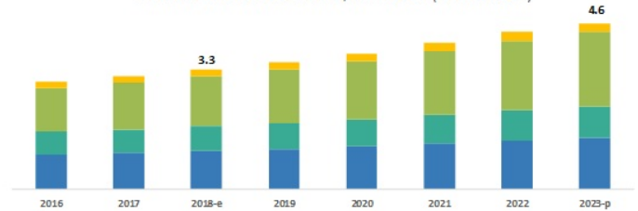

**Figure 4.3: Cloud base system impact on operational profit**

(Source: Dhakal, 2020)

Operational activities in human and Logistic required continuous communication between employees to mitigate operational errors and produce better activities. Implementation of cloud-based systems in the pneumatic industry also delivered a positive impact on time management. According to Sinaga *et al.* (2021), the processing of productivity could enhance the productivity process of the Pneumatic industry through implementation of artificial intelligence-based communication programs to get input device planning of operations to improve wise collection of resources and distribution of energy to customers.

Analyzing process organized Industry productivity evaluate what is population of production would be possible by resource management. Conjunction of electricity and other resources delivered negative results to profitability as a conjunction of cost which could be enhanced by automatic machinery program. According to Challa & Das, (2019), installation of new technology in production of energy saves over consumption of cost and explains the search by producing the maximum amount of energy produced, the average cost of production and helps to compete in the comparative market. There are four components that have been used in the pneumatic industry like reservoir/receiver, pump/compressor, valve, and cylinder to continue the operation for more productivity and energy for supply. Opined by Białobłocki, K. (2021), requirement energy in operational growth has been conducted through proper resource management and allocation of human resource for each activity that conducted better growth of production in the pneumatic industry.

## 4.3 Summary

This section has been conducted to summaries finding and analyses regarding procurement and Logistics support toward the pneumatic industry. Findings analysis technology investment is required to improve productivity for this industry and also deliver effective growth in profitability by enhancing growth of operations. This an organization involved in this industry can further complement better time allocation and cost savings when all operations are conducted within prescribed specifications and requisite legislations are being adhered fruitfully. Continuous progression in operational activity would be improved by Logistic support that could be developed for the implementation of Technologies like cloud-based system and machine learning programs. Which industry took your energy and restored it to supply whereas it could be effective by implementation of a distribution channel. Supply chain management is effective to this organization by distribution Corporation passes through diversified planning that develops productivity of organization and improvises growth potentiality. Generally, the available modes of transportation are considered to be either railway, roadways, airways and ships and fixing a particular mode of transportation further benefits an organization to comply with cost savings.

# References

Alfnes, E., Gosling, J., Naim, M., & Dreyer, H. C. (2021). Exploring systemic factors creating uncertainty in complex engineer-to-order supply chains: Case studies from Norwegian shipbuilding first tier suppliers. *International Journal of Production Economics*, *240*, 108211. https://www.sciencedirect.com/science/article/pii/S0925527321001870

Babii, A. (2020). Important aspects of the experimental research methodology. *Вісник Тернопільського національного технічного університету*, *97*(1), 77-87. Retrieved from: http://elartu.tntu.edu.ua/bitstream/lib/32426/2/TNTUSJ_2020v97n1_Babii_A-Important_aspects_of_the_experimental_77-87.pdf

Basias, N., & Pollalis, Y. (2018). Quantitative and qualitative research in business & technology: Justifying a suitable research methodology. *Review of Integrative Business and Economics Research*, *7*, 91-105. Retrieved from: https://sibresearch.org/uploads/3/4/0/9/34097180/riber_7-s1_sp_h17-083_91-105.pdf

Białobłocki, K. (2021), POLITICAL, SOCIO-ECONOMIC AND SYSTEM MODERNIZATION AS COMPONENTS OF A LOGISTIC-TRANSFORMATIONAL PLAN AND PROCESS IN THE POST-COMMUNIST COUNTRIES OF CENTRAL-EASTERN EUROPE. Wyższej Szkoły Gospodarki Krajowej w Kutnie, 180. http://jcee.wsgk.com.pl/wp-content/uploads/jcee/Nr%209/Studium%20Europy%20Srodkowej%20i%20Wschodniej%20NR9%20czerwiec%202018_2.pdf#page=180

Challa, P. R., & Das, B. B. (2019). Methods to monitor resources and logistic planning at project sites. In Sustainable Construction and Building Materials (pp. 793-802). Springer, Singapore. https://link.springer.com/chapter/10.1007/978-981-13-3317-0_71

Changalima, I. A., Mushi, G. O., & Mwaiseje, S. S. (2020). Procurement planning as a strategic tool for public procurement effectiveness: experience from selected public procuring entities in Dodoma city, Tanzania. *Journal of Public Procurement*, DOI 10.1108/JOPP-05-2020-0047

Changalima, I. A., Mushi, G. O., & Mwaiseje, S. S. (2020). Procurement planning as a strategic tool for public procurement effectiveness: experience from selected public procuring entities in Dodoma city, Tanzania. Journal of Public Procurement. https://www.emerald.com/insight/content/doi/10.1108/JOPP-05-2020-0047/full/html

Chen, X., Zheng, F., Gan, W., & Xing, S. (2022). Exploration and Research on Key Technologies for Improving the Response Speed of Servo-Hydraulic Cylinders. *Applied Sciences*, *12*(9), 4162. https://www.academia.edu/download/88183000/Design_and_Analysis_of_Component_of_Hydraulic_Gripper.pdf

Chepkesis, K., Keitany, P., & Kiplel, M. (2018). Effect of Procurement Planning on Suppliers Performance in Public Institutions: A Case of Moi University. *European Journal of Logistics, Purchasing and Supply Chain Management*, *6*(2), https://www.researchgate.net/profile/Maureen-Kiplel/publication/338936760_EFFECT_OF_PROCUREMENT_PLANNING_ON_SUPPLIERS_PERFORMANCE_IN_PUBLIC_INSTITUTIONS_A_CASE_OF_MOI_UNIVERSITY/links/5e33f24192851c7f7f0ede36/EFFECT-OF-PROCUREMENT-PLANNING-ON-SUPPLIERS-PERFORMANCE-IN-PUBLIC-INSTITUTIONS-A-CASE-OF-MOI-UNIVERSITY.pdf

Cherier, M. A., Bennekrouf, M., & Meliani, S. M. (2020, December). The Application of AHP-TOPSIS Methodology for Selection of Agriculture Farms in Tomato Processing Industry: Algerian Case Study. In *2020 IEEE 13th International Colloquium of Logistics and Supply Chain Management (LOGISTIQUA)* (pp. 1-5). IEEE. https://ieeexplore.ieee.org/abstract/document/9353915/

Cirianni, F., Panuccio, P., & Rindone, C. (2021). A comparison of urban planning systems between the UK and Italy: Commercial development and city logistic plan. WIT Transactions on the Built Environment, 130, 785-797. https://www.witpress.com/elibrary/wit-transactions-on-the-built-environment/130/24575

Deaconescu, T., & Deaconescu, A. (2022). Experimental Research on Polymer-Based Coaxial Sealing Systems of Hydraulic Cylinders for Small Displacement Velocities. *Polymers*, *14*(2), 290. https://doi.org/10.3390/polym14020290

Dhakal, B. (2020). Learning about procurement process in Logistic Management Division, DOHS (Doctoral dissertation, Brac University). https://journals.vilniustech.lt/index.php/JCEM/article/view/16681

Dong, Q., Li, R., & Kang, R. (2022). System Resilience Evaluation and Optimization Considering Epistemic Uncertainty. *Symmetry*, *14*(6), 1182. https://doi.org/10.3390/sym14061182

Dźwigoł, H. (2018). Scientific research methodology in management sciences. *Фінансово-кредитна діяльність: проблеми теорії та практики*, (2), 424-437. Retrieved from: http://dspace.vnbrims.org:13000/jspui/bitstream/123456789/4653/1/Fundamentals%20of%20Research%20Methodology_Nayak.pdf

Engel-Cox, J., Oakleaf, B. M., Heath, G. A., Logan, J. S., Macknick, J. E., McCall, J. D., & Statwick, P. (2019). Innovations in Upstream Oil and Gas Operations in Close Proximity to Communities, https://www.nrel.gov/docs/fy19osti/72151.pdf

Ezpeleta Laskurain, I. (2021). Design to cost; a framework for large industrial products, 10.1016/j.procir.2021.05.036

Fargnoli, M., Haber, N., & Tronci, M. (2022). Case study research to foster the optimization of supply chain management through the PSS approach. *Sustainability*, *14*(4), 2235. https://www.mdpi.com/1501078

Gencer, Y. G. (2019). Supply Chain Modernization: The Case of Turkish Companies in 3PL and 4PL Logistics Applications. In *The Circular Economy and Its Implications on Sustainability and the Green Supply Chain* (pp. 168-176). IGI Global. https://www.igi-global.com/chapter/supply-chain-modernization/220291

Gholizadeh, H., Fazlollahtabar, H., & Khalilzadeh, M. (2020). A robust fuzzy stochastic programming for sustainable procurement and logistics under hybrid uncertainty using big data. *Journal of cleaner production*, *258*, 120640, https://doi.org/10.1016/j.jclepro.2020.120640

Greening, N., (2019). Phenomenological research methodology. *Scientific Research Journal*, *7*(5), pp.88-92. Retrieved from: https://www.researchgate.net/profile/Neville-Greening/publication/337106850_Phenomenological_Research_Methodology/links/620f3cefeb735c508add7902/Phenomenological-Research-Methodology.pdf

Hashemi, A., Esrafilian, R., Hadavand, S., & Zeraatkar, M. (2020). Application of fuzzy TOPSIS for evaluation of green supply chain management practices (case study: Zanjan Sepehr Khodro; Iran). *Int. J. Eng. Technol.*, *11*(6), 13-24. https://www.researchgate.net/profile/Ahmad-Hashemi-3/publication/338857003_Application_of_Fuzzy_TOPSIS_for_Evaluation_of_Green_Supply_Chain_Management_Practices_Case_study_Zanjan_Sepehr_Khodro_Iran/links/5fba4a35a6fdcc6cc65a6a9e/Application-of-Fuzzy-TOPSIS-for-Evaluation-of-Green-Supply-Chain-Management-Practices-Case-study-Zanjan-Sepehr-Khodro-Iran.pdf

Jordon, K., Dossou, P. E., & Junior, J. C. (2019). Using lean manufacturing and machine learning for improving medicines procurement and dispatching in a hospital. *Procedia Manufacturing*, *38*, 1034-1041, 10.1016/j.promfg.2020.01.189

KAMENDU, C. S. (2020). Assessment on Factors affecting Preparation and implementation of Annual Procurement Plan in Public Institutions In Tanzania” a case of Mbeya Referral Regional Hospital (Doctoral dissertation, Mzumbe University). http://scholar.mzumbe.ac.tz/handle/11192/3834

Karpova, N. P. (2019). Strategic planning in logistic systems. Актуальні проблеми економіки, (2), 31-37. http://www.irbis-nbuv.gov.ua/cgi-bin/irbis_nbuv/cgiirbis_64.exe?C21COM=2&I21DBN=UJRN&P21DBN=UJRN&IMAGE_FILE_DOWNLOAD=1&Image_file_name=PDF/ape_2015_2_6.pdf

Kołakowski, T. (2022). Logistic decisions in the management of cultural heritage at the strategic level of functioning of museum. In Proceedings of The 6th International Virtual Scientific Conference on Informatics and Management Sciences (pp. 42-47). https://www.researchgate.net/profile/Tomasz-Kolakowski/publication/316764006_Logistic_decisions_in_the_management_of_cultural_heritage_at_the_strategic_level_of_functioning_of_museum/links/5910f5150f7e9bfa06b4d2ff/Logistic-decisions-in-the-management-of-cultural-heritage-at-the-strategic-level-of-functioning-of-museum.pdf

Kungwalsong, K., Mendoza, A., Kamath, V., Pazhani, S., & Marmolejo-Saucedo, J. A. (2022). An application of interactive fuzzy optimization model for redesigning supply chain for resilience. *Annals of Operations Research*, 1-37. https://link.springer.com/article/10.1007/s10479-022-04542-5

Liu, W., Liu, X., & Choi, T. M. (2022). Effects of supply chain quality event announcements on stock market reaction: an empirical study from China. *International Journal of Operations & Production Management*, (ahead-of-print). https://www.emerald.com/insight/content/doi/10.1108/IJOPM-10-2021-0638/full/html

Logistics UK (2021), *The Logistics Report Summary 2021*, https://logistics.org.uk/CMSPages/GetFile.aspx?guid=68631c02-c41f-40e8-99b3-fa9b60832742&lang=en-GB

Mohajan, H. K. (2018). Qualitative research methodology in social sciences and related subjects. *Journal of economic development, environment and people*, *7*(1), 23-48. Retrieved from: http://dspace.vnbrims.org:13000/jspui/bitstream/123456789/4666/1/RESEARCH%20METHODOLOGY%20TOOLS%20AND%20TECHNIQUES.pdf

Nagurney, A., Salarpour, M., & Daniele, P. (2019). An integrated financial and logistical game theory model for humanitarian organizations with purchasing costs, multiple freight service providers, and budget, capacity, and demand constraints. *International Journal of Production Economics*, *212*, 212-226, https://supernet.isenberg.umass.edu/articles/Integrated_FinancialandLogistical_GameTheoryModel_for_HumanitarianOrganizations.pdf

Nemati, Y., & Alavidoost, M. H. (2019). A fuzzy bi-objective MILP approach to integrate sales, production, distribution and procurement planning in a FMCG supply chain. *Soft computing*, *23*(13), 4871-4890, https://doi.org/10.1007/s00500-018-3146-5

Newman, M., & Gough, D. (2020). Systematic reviews in educational research: Methodology, perspectives and application. *Systematic reviews in educational research*, 3-22. Retrieved from: https://library.oapen.org/bitstream/handle/20.500.12657/23142/1007012.pdf?sequence=1#page=22

Newman, M., & Gough, D. (2020). Systematic reviews in educational research: Methodology, perspectives and application. *Systematic reviews in educational research*, 3-22. Retrieved from: https://library.oapen.org/bitstream/handle/20.500.12657/23142/1007012.pdf?sequence=1#page=22

Ngozwana, N. (2018). Ethical dilemmas in qualitative research methodology: Researcher’s reflections. *International Journal of Educational Methodology*, *4*(1), 19-28. Retrieved from: https://dergipark.org.tr/en/download/article-file/488890

Ngozwana, N. (2018). Ethical dilemmas in qualitative research methodology: Researcher’s reflections. *International Journal of Educational Methodology*, *4*(1), 19-28. Retrieved from: https://dergipark.org.tr/en/download/article-file/488890

Odume, B., Meribe, S. C., Odusote, T., Ifunanya, M., Debem, H., Amazue-Ezeuko, I., ... & Onotu, D. (2020). Taking tuberculosis preventive therapy implementation to national scale: the Nigerian PEPFAR Program experience. Public Health Action, 10(1), 7-10. https://ojs.aaresearchindex.com/index.php/aasgbcpjmra/article/view/2223

Patel, M., & Patel, N. (2019). Exploring Research Methodology. *International Journal of Research and Review*, *6*(3), 48-55. Retrieved from:  https://www.academia.edu/download/63543152/IJRR001120200605-115829-bxlrli.pdf

Patel, M., & Patel, N. (2019). Exploring Research Methodology. *International Journal of Research and Review*, *6*(3), 48-55. Retrieved from: https://www.academia.edu/download/63543152/IJRR001120200605-115829-bxlrli.pdf

Ragab, M.A. & Arisha, A., (2018). Research methodology in business: A starter’s guide. *Management and organizational studies*, *5*(1), pp.1-14. Retrieved from: https://www.researchgate.net/profile/Mohamed-Ragab-22/publication/321769066_Research_Methodology_in_Business_A_Starter's_Guide/links/5a311456aca2724bf72185bf/Research-Methodology-in-Business-A-Starters-Guide.pdf

Ragab, M.A. & Arisha, A., (2018). Research methodology in business: A starter’s guide. *Management and organizational studies*, *5*(1), pp.1-14. Retrieved from: https://www.researchgate.net/profile/Mohamed-Ragab-22/publication/321769066_Research_Methodology_in_Business_A_Starter's_Guide/links/5a311456aca2724bf72185bf/Research-Methodology-in-Business-A-Starters-Guide.pdf

Röhm, B., & Anderl, R. (2022). Simulation Data Management in the Digital Twin (SDM-DT)–Evolution of Simulation Data Management along the Product Life Cycle. *Procedia CIRP*, *105*, 847-850. https://www.sciencedirect.com/science/article/pii/S221282712200141X/pdf?md5=5dee90a9b59195849cfc288fb79547c9&pid=1-s2.0-S221282712200141X-main.pdf

Sinaga, O., Baker, R., Amirul, A. S., Saudi, N. S. M., & Nazri, N. S. M. (2021). Assessing the Effectiveness of Procurement Systems and Geographic Location in Achieving Service Quality in Public Sector. Geographical Education (RIGEO), 11(1), 677-684. https://www.ajol.info/index.php/rjmhs/article/view/214261

The World Bank (2022), *Connectivity, Logistics & Trade Facilitation*, https://www.worldbank.org/en/topic/trade-facilitation-and-logistics

UK, W. E. C. (2020). Energy Engineering, https://energyengineering.co.uk/wp-site/wp-content/uploads/2022/01/EE-Southern-Manufacturing-32pp-Jan-Feb-22.pdf

Willmott, H., (2020). On research methodology. *The Journal of Organization and Discourse*, *1*(1), pp.1-4. Retrieved from: https://www.jstage.jst.go.jp/article/jscos/1/1/1_1/_pdf

Willmott, H., (2020). On research methodology. *The Journal of Organization and Discourse*, *1*(1), pp.1-4. Retrieved from: https://www.jstage.jst.go.jp/article/jscos/1/1/1_1/_pdf

Yang, J., & Yu, K. (2019). The role of an integrated logistics and procurement service offered by a 3PL firm in supply chain. *Journal of Management Analytics*, *6*(1), 49-66, https://doi.org/10.1080/23270012.2019.1568921